User Requirement Specification
FOR
Volunteer Management System
(VMS)

CLIENT | The Client
PROJECT | Volunteer Management System (VMS)Volunteer Management System
TITLE | User Requirement Specification
VERSION | 1.11.0
DATE | 03 Sep 2011
 | ORIGINATOR
 | Name / Signature | Hnin Nu Aye and Thida Khin Myo Thaung
 | APPROVAL
 | Name / Signature | Phung Kim Cuong, Dio
Institute of Systems Science |  | Document Reference
25 Heng Mui Keng Terrace  Singapore 119615 |  | VMS/T-1.2/1.1VMS/T-1.2/1

 | Acceptance
 | Customer Signature |  | Customer Signature
 | Name & Designation |  | Name & Designation
 | Date & Company Stamp |  | Date & Company Stamp

Revision History

Date | Version | Description | Author
02 Apr 2011 | 1.0 | Initial release | Hnin Nu Aye and Thida Khin Myo Thaung
03 Sep 2011 | 1.1 | Refer to Appendix D Amendment History | Hnin Nu Aye and Thida Khin Myo Thaung

Table of Contents

1. INTRODUCTION 3
1.1 Background 3
1.2 Objectives 3
1.3 Organisation 3
1.4 Scope 3
1.5 Definition of Terms 3
2. OVERVIEW OF REQUIREMENTS 4
2.1 Introduction 4
2.2 System Perspective 4
2.3 System Functions 4
2.4 User Characteristics 5
2.5 General Constraints 5
2.5.1 Software Limitations 5
2.5.1.1 Server 5
2.5.1.2 Client 6
2.5.1.3 Development 6
2.5.2 Hardware Limitations 6
3. FUNCTIONAL REQUIREMENTS 7
3.1 Processing Requirements 7
3.1.1 Security Management 7
3.1.2 Volunteer Management 8
3.1.3 Project Management 14
3.1.4 Certificate Management 17
3.2 User Interface Requirements 18
4. OPERATIONAL AND QUALITY REQUIREMENTS 19
4.1 Operating Environment 19
4.2 Development Constraints 19
5.3 Development Platform and Frameworks 19
4.3 Performance 19
4.4 Reliability 19
4.5 Availability 20
4.6 Capacity and Expandability 20
4.7 Security 20
4.8 Future Growth 20
ANNEX D: Amendment History 21

INTRODUCTION

Background
The consulted organisation is poverty elimination Non-Government Organisation (NGO). It has grown tremendously over the years and is attracting more and more volunteers both domestically and internationally. As it grows, there is an increasing need to coordinate and manage its volunteers, especially international volunteers as they require more administrative and logistic efforts. The current ways of manually handling documents and volunteers requires a lot of works and limiting the organisation efficiency.
From the situational analysis and problems identified, our team proposed an integrated System with the aim of addressing the problems of volunteer communication, documentation, recruitment and retention.

Objectives
The objectives of this document are to:
- Define the functional requirements for the Volunteer Management System (VMS).
- Define the non-functional (i.e. operational and quality) requirements that would be necessary to support the functional requirements
- Define the operational environment of the System.

Organisation
- Section 1 gives an introduction to this document.
- Section 2 presents an overview of requirements for the System.
- Section 3 presents the functional requirements and
- Section 4 describes the operational and quality requirements.

Scope
This user requirement specification is solely concerned with the development of the VMS.

Definition of Terms
The following terms have special meanings within this document:
- The word shall imply a mandatory requirement.
- The word should imply a desirable requirement.
- The word will imply a mandatory requirement outside the scope of this document.
- The word may imply a desirable requirement outside the scope of this document.

OVERVIEW OF REQUIREMENTS

Introduction
The Volunteer Management System (VMS) operates and maintains a large number of volunteer information and project information. Previously, this information is controlled manually. With the fast organisation growth, it is very difficult to maintain and manipulate all the information manually and the organisation has been decided to move to a computerised control System that will be access through intranet and internet.

System Perspective
The VMS allows the volunteers to register their own account, allow them to post feedback to the project about their experience and suggestions, and share their inspirational stories to the community. By providing such features will support the fast growth of organisation with different insights and knowledge from different people. It also allows the internal staff to maintain the project related information such as project details, itinerary plan, project calendar, project member and reporting features which allow NGO to perform business planning and statistical analysis of the organisation.

System Functions
System functions to be implemented are:

No. | Module | Functions
 | Login | - Login
 | Volunteer Management | - Register Volunteer Account  - Update Volunteer Profile  - Forget Password  - Change Password  - Browse for Projects  - Raise Interest to Project  - Review Project Interest by Volunteer and Assign volunteer to Project  - Post Feedback to Project  - Post Experience or Inspiration Stories  - Review and Reply Feedback  - Request for Certificate
 | Project Management | - Propose Project  - Review and Reply Project Proposal  - Set-up Project Details  - Manage Projects  - Review Project Interest by Volunteer and Assign volunteer to Project  - Assign Roles to Project Member  - Send invitation to volunteer
 | Certificate Management | - Generate Certificate  - Print Certificate

User Characteristics
- For each project, the volunteer can play the following roles:
- acting as the project leader, who will manage a specific project (or)
- acting as the project member
- The Internal Staff can play the following roles:
- acting as the Project Manager, who will manage one or more projects (or)
- acting as the System Administrator, who will manage staff account and configure System parameters (or)
- acting as the Administrator, who will manage volunteer account, generate report and certificate
- acting as the project Coordinator who will manage the project proposal and project itinerary plan approval
- Each user can play more than one role.

General Constraints

Software Limitations

Server
The server shall need Windows/ Linux / any O/S capable of hosting Java Runtime Environment 1.5, MySQL 5.0 and Apache Tomcat 6.0.

Client
System shall need Internet Explorer 6.0+ or Mozilla Firefox 2.0+.

Development
Java Development Environment 1.5 or greater, Eclipse JEE IDE shall be used in the development of VMS.

Hardware Limitations
Each user shall need a PC capable of running Microsoft Windows XP or greater.
The database shall be stored on a server capable of running MySQL 5.0, and all servers shall need to be networked together so that all can have access to the database.

FUNCTIONAL REQUIREMENTS
This section describes the functional requirements of the VMS, which shall be referred to as the System. The functional requirements are structured in terms of:
- Processing requirements – the main software functions to be provided
- User interface requirements – the required user interface to support the software functions.

Processing Requirements
The System is required to provide the software functions necessary for the application to manage volunteer and project information and for the volunteers and internal staff to perform their roles in using the System. General Information about the organisation will be published to the members of the Public before they decide to register as a volunteer. These functions are described in the following subsections.

Security Management

Login / Logout

- The System shall allow the user to login to the System by entering the following information:
  - Registered User Name
  - Password
- The error message will be displayed if the provided email address or password is incorrect.
- The informational message will be displayed when the account is disabled by the System admin.
- The users can logout of the system by clicking the Logout button.

Volunteer Management
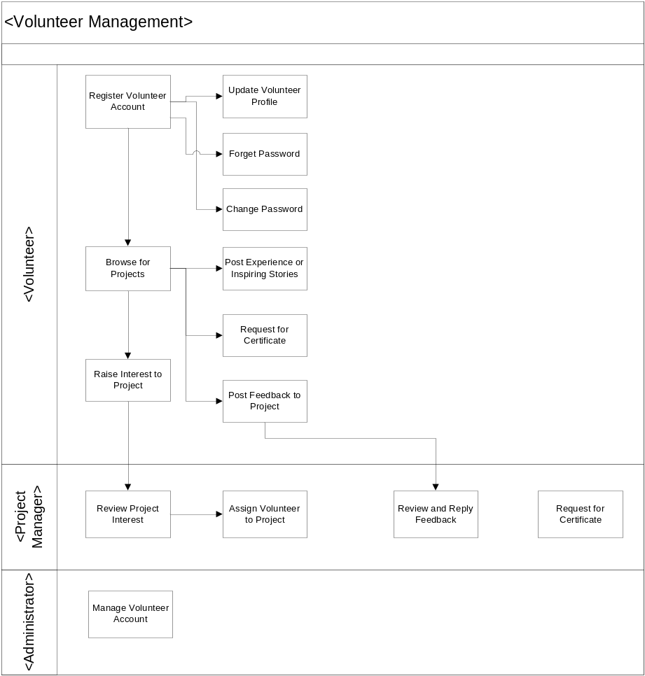
Figure 1 Volunteer Management Business Workflow Overview

Register Volunteer Account
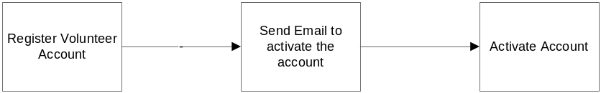
- Upon interesting to become a volunteer, one can register as the volunteer by signing up for a volunteer account through System. The following information are required to be input into the System for registration of a volunteer account:
- Email Address
- Password
- The System shall verify that the account user name has not already existed in the System before creation of the account. If the account is registered, the System will prompt the error to indicate this account is already registered, otherwise the System will create this new account for the volunteer
- After registration of account, the volunteer may then proceed to update his/her profile

- Update Volunteer Profile

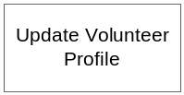
- The System shall allow the volunteer to update the following information for an activate account.
  - Title( Mr. , Mrs. , Ms., Dr., Other)
  - First Name
  - Last Name
  - Address
  - Country

  - Phone(Home)
  - Phone(Mobile)
  - Date of Birth
  - Hobbies/ Interests
  - Special Skills
  - Qualifications attained (Education)
  - Qualifications attained (Others)
  - Languages
  - Volunteer Interests (Admin, Befriending, Events (organizing), General Services, IT, Research, Marketing/Publicity, Skilled Services, Others)
Note that these fields are read-only:
  - Join Date
  - Email Address

Forget Password
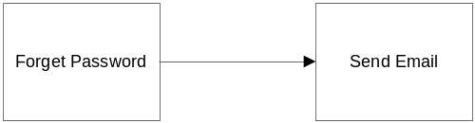
- The System shall allow the volunteer to retrieve his password if (s) he forgets. It shall ask the user to input the
  - Email Address
  - Secret Question
  - Secret Answer

- If the email address is valid (i.e. the email address is the same as the registered email address in the system) and the Secrete Question and Secrete Answer match, an email notification will be sent to the volunteer together with the newly generated password.
- If the email address is not existent in the system, or the answer and secret question are not matching, the system shall display an error message.

      - Change Password
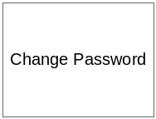
- The System shall allow the volunteer to change password at any time. The volunteer will need to specify:
  - Email Address
  - Old Password
  - New Password
  - Confirm New Password
- An error message will be displayed if email address and old password is not matching the record in the System; or if the new password and confirm new password are not the same.

      - Browse for Project

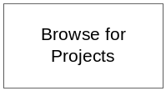
- The System shall allow public user (or anonymous user) to browse the list of projects with:
  - Project Name
  - Project Description (Activities / Location / Duration …etc.)
- After the volunteer log in to the System, the System shall display all the projects, either:
  - The projects that the volunteer joined or that he is currently joining
  - Active projects which are currently in progress.
- For the listed projects,
- the System shall display the project information and
  - The status of the volunteer’s request to join to the project (if there is any)
    - Requested (Request the project to join)
    - Withdraw (Withdraw from the project by Volunteer)
    - Rejected (Request to join the project is rejected by PM. The volunteer can see the reason by PM)
    - Unsuccessful (There is more than one request to join the projects for the overlap period. When the volunteer is accepted by one project, the other project request for the overlap period will be reflected as Unsuccessful. The volunteer can see the comment which is auto generated by the system)
- All the past project from 2 months ago or for a specified period which is defined by the volunteer

Raise Interest to join Project

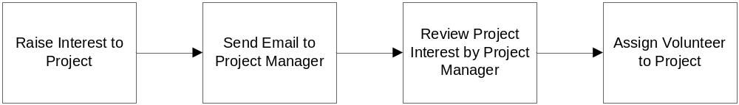
- For the active projects which do not start yet and which require more volunteers, the volunteer can raise the interest to the Project Manager. The volunteer can raise more than one project at a time.
- The System shall send the email to the relevant project manager when there is the interest request to the project.
- The project request status is in Requested means that the PM hasn’t decided to let the volunteer join the project, if the volunteer want to cancel his request, the System shall allow canceling it.
- The System shall send the email to the relevant project manager about the request cancellation

Review Project Interest and Assign Volunteer to Project

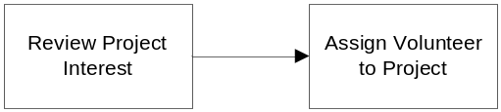
- The System shall allow the project manager to review the list of requested volunteer who want to join to a specific project. The System shall display the following information of the volunteer:
  - Title( Mr. , Mrs. , Ms., Dr., Other)
  - First Name
  - Last Name
  - Address
  - Country
  - Age
  - Hobbies/ Interests
  - Special Skills
  - Qualifications attained (Education)
  - Qualifications attained (Others)
  - Languages
  - Volunteer Interests (Admin, Befriending, Events (organizing), General Services, IT, Research, Marketing/Publicity, Skilled Services, Others)
  - Availability Status
  - Join Date (Read Only)
- If the volunteer submit request for two projects which falls on the same or overlap duration and one project manager already accepts him or her, the next project manager will see his availability status as Occupied and the PM shall not be able to assign him to his project.
- The project manager can accept/reject the volunteer request.
- When the project manager accept a volunteer request to join his project,
  - The System shall check if there is the other project request which fall the same period. If there is the request for the same project period, the project request status will be updated from Requested to Unsuccessful
  - The System will send the notification email to that volunteer about approval.
  - The System will add the volunteer account to the list of member in this project and allow the Project manager to select the roles for the members.
- When the project manager reject a volunteer request to join his project,
  - The project request status will be updated from Requested to Rejected
  - The System will send the notification email to that volunteer about rejection.

Post Experience or Inspiring Stories
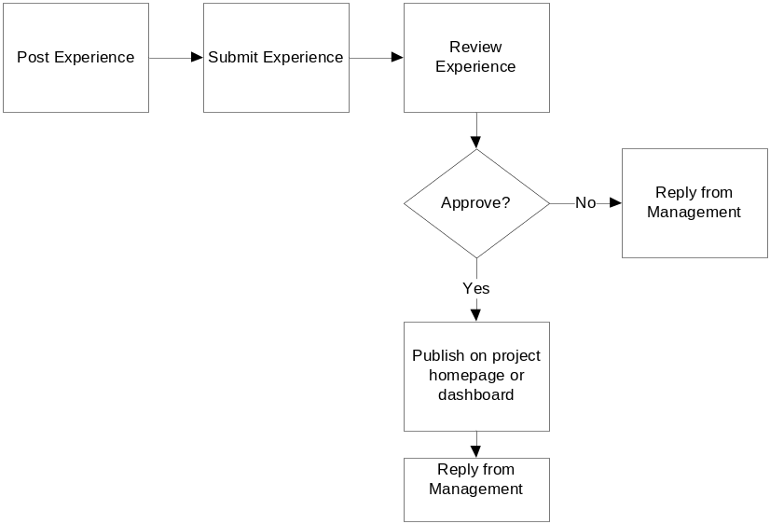
- The System shall allow the volunteer to post the experience/inspiring stories to all kind of projects (Ongoing/Currently Joined/Past Projects)..
- The System shall allow the experience / stories to be modified or deleted by the poster before the PM approval.
- The System shall not allow that experience / stories to be modified or deleted by the poster after the PM approval.
- The System shall display the approved experience / stories on the homepage or dashboard of a project to all volunteers

Post Feedback


- The System shall allow the volunteer to post their feedback regarding any matter of the projects that he or she has joined or is currently joining.

- The System shall allow the feedback to be modified or deleted only by the owner.

Review and Reply Feedback


- The PM should check the posted feedback regularly for the projects he is in charge. The System shall allow the PM to view the feedback and response to the feedback. (Note: Following up with the feedback is the outside the scope of the System.)

Request for Certificate
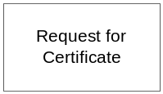
- The System shall allow users to send the request for the Project Participation Certification to the System Administrator.
- The request can be done by two roles:
  - Project Manager (When the project is finished, project manager can send request the certificate for the whole team or individual)
  - Volunteer ( When the volunteer want the certificate for a particular project he joined, volunteer can send the request)
- The System shall send the notification email to all the people with System Administrator role to inform them of the request.

Project Management
    - Overall processes workflow
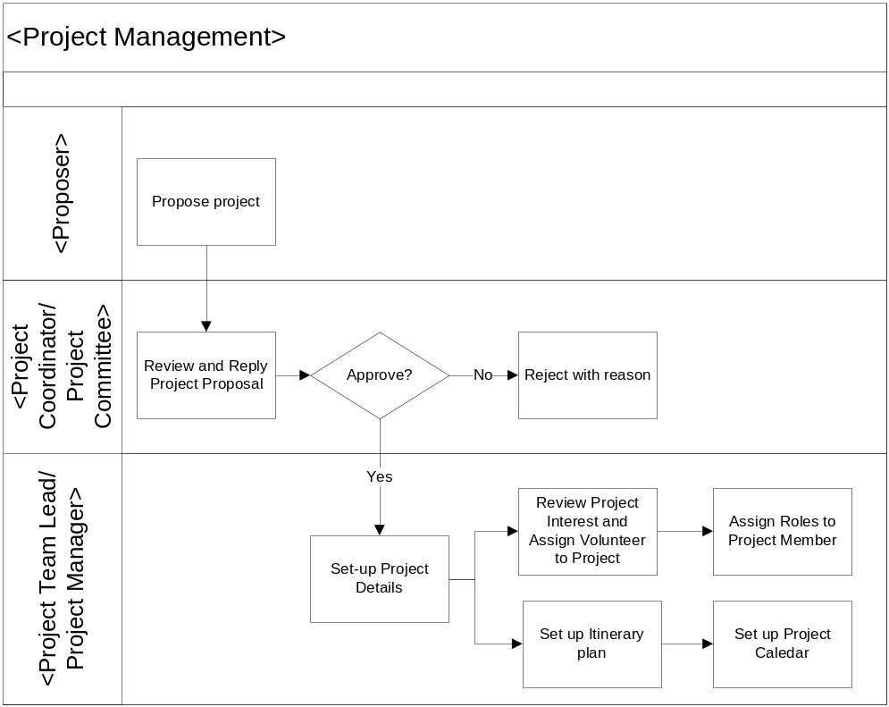
Figure 3 Project Management Business Flow Overview

Propose Project

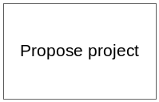
- The System shall allow the volunteer or internal staff to propose the project to the organisation. The System shall accept the following details of the proposal.
  - Project Name
  - Project Description
  - Country
  - Location
  - Estimated Duration
  - Proposer
  - Created Date
- The System shall allow the volunteer or internal staff to view the proposal records and the status of the project proposal. The submitted proposal will have the following status:
  - Submitted (When the proposal is submitted to the Project Coordinator)
  - Rejected (When the proposal is rejected by the Project Coordinator)
  - Approved (When the proposal is approved by the Project Coordinator)
- The System shall also allow these details to be recalled and displayed.
- The System shall also allow these details to be modified by the owner before the approval.
- The System shall send the email to Project Coordinator about the submitted proposal. The Project Coordinator will review the Project Proposal with the Project Committee and this will be outside of the System.

Review and Reply Project Proposal


- The System shall allow the project coordinator to review the Project Proposal information. In fact, the project coordinator will review the proposal with the relevant project committee members and which is outside of the System.
  - Project Name
  - Project Description
  - Country
  - Location
  - Estimated Duration
  - Proposer
  - Created Date
- The System shall allow project coordinator approving/rejecting the project proposal according to the decision of the project committee. The System will send the notification email to the proposer about the approval or rejection by the project coordinator.

Manage Projects

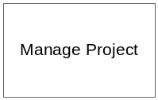
- The System shall allow all the staff with project manager role to view the project details such as
  - Project Name
  - Project Description
  - Country
  - Project Location
  - Start Date
  - Project Status(Coming, On Going, Closed)
  - Project Manager
  - Created Date
  - Project Progress Percentage
  - List of project members
- The System shall allow the relevant project manager to modify his/her projects
  - Project Name
  - Project Description
  - Project Location
  - Country
  - Start Date
  - End Date
  - Project Status(Coming, On Going, Closed)
  - Created Date(Read Only)
  - Project Progress Percentage
- The System shall not allow the PM to delete the project.

Review Project Interest by Volunteer and Assign Volunteer to the Project

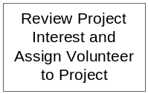
- Refer to 3.1.2.14

Assign Roles to Project Member


- The System shall allow the PM to assign roles to project members.

- The System shall also send the notification email to assigned volunteer.

Send Invitation to Volunteer

- The System shall allow the PM of the project to send email invitation to all registered volunteers. The email will contain the link so that the volunteers can see the project details and can raise interest to join project.

The System shall also send the notification email to assigned volunteer

Certificate Management

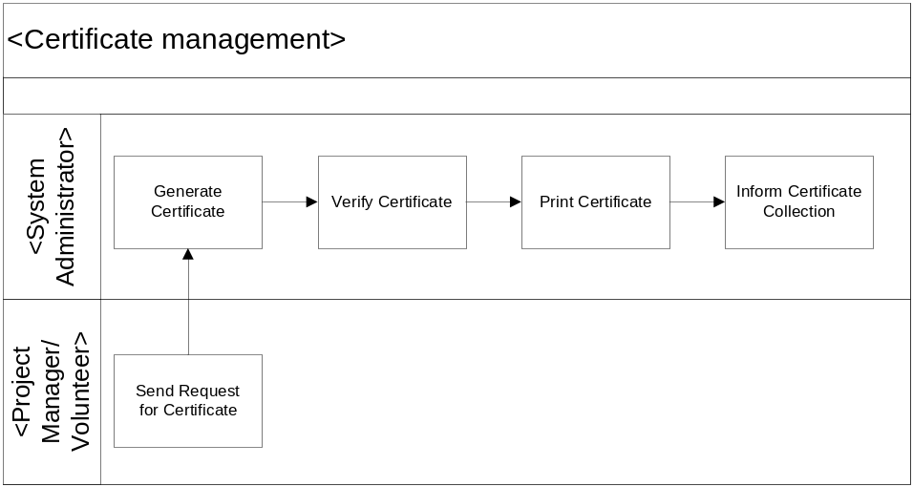
Figure 5 Certificate Management Business Flow Overview

Generate Certificate

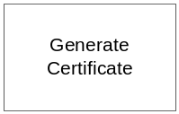
- When the volunteer or project manager request for the certificate, all the staff with System administrator roles will receive the notification email. One of the System administrators will handle the request.
- The System shall allow the System admin to generate the certificate based on:
  - Whole Project (for all project members)
  - A specific project member

User Interface Requirements
- Web Page should be user friendly with minimal steps required.
- Web page should not include typos, no misalignment.
- Master page/common theme will be applied to all major pages: popup page/message page will not needed master page/theme.
- UI will have to compatible with most common browser Internet Explorer and Firefox

OPERATIONAL AND QUALITY REQUIREMENTS

Operating Environment
The VMS system shall operate in Internet and Intranet environment. Server system shall operate on any server O/S that is capable of hosting the VMS application. System run time environment should be JRE 1.6 and above. Web server shall be Apache HTTP Server 2.2.7. Two Application servers/ application instances shall be used Apache Tomcat 6.0+. Based on the application work load, a number of instances can be added up without the software modification. All the application data shall be stored on MySQL 5.0 and above. Minimum requirement for user’s web browser/ client shall be Internet Explorer 6.0 +, Firefox 2.0.+.

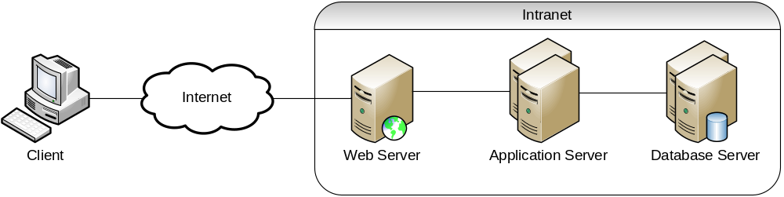

Figure 7 Logical System Diagram

Development Constraints
The software shall be designed using the Rational Unified Process. Integrated development environment shall be Eclipse Java EE IDE for Web Developers. JDK 1.6 shall be used for software development. Apache Ant1.8 shall be used for source compilation.

Development Platform and Frameworks
Hibernate 3 for database and object mapping , Spring 2.5 for a layered Java/J2EE application platform, Direct Web Remoting Java library that enables Java on the server and JavaScript in a browser to interact and call each other as simply as possible.

Performance
The system shall maintain an average of 2 seconds to response to every DWR request from Intranet user or Internet user. The system shall maintain an average of 5 seconds to response to every http request from intranet user or internet use. (Based on two instance servers)

Reliability
The combined hardware and software system shall have 99% reliability. In particular during a 24 hour running period the system should not be unavailable for a period longer than 2 hours in total.

Availability
The system shall be available 24 hours a day, 7 days / 167.5 hour a week with 99% availability per year. The application servers and database servers shall offline 30 minutes for scheduled maintenance every Sunday on the second week of the month.

Capacity and Expandability
The design of the system shall be flexible in order to allow modifiability of the system.

Security
The VMS system shall used Spring Security for access control. User information such as user name and password shall store in VMS database. Password encryption shell implemented using SHA-1 or any standard encryption in the industry. VMS require all users to enter a valid password to logon to the system. Each user will be granted access only to functions that are compatible with their responsibilities/ role.

Future Growth
The system should be designed such that only minimal changes are required to modify it to meet the requirements of the volunteer management system.

ANNEX D: Amendment History

This is a record of all amendments made to the Document.
Version | Chapter / Section | Page No | Notes of Amendments or Changes
1.1 | 3. Functional Requirement | 8-28 | - Updated some use case detail  - Fixed typos / fragmented sentences
1.1 | 2. Overview of requirement  3. Functional Requirement  4. Operational and Quality Requirement | All | - Updated some use case detail  - Update requirement for hardware and environment
1.1 | Section 3 | 8-28 | - Update the processing requirements: remove use cases for itinerary management and staff management

